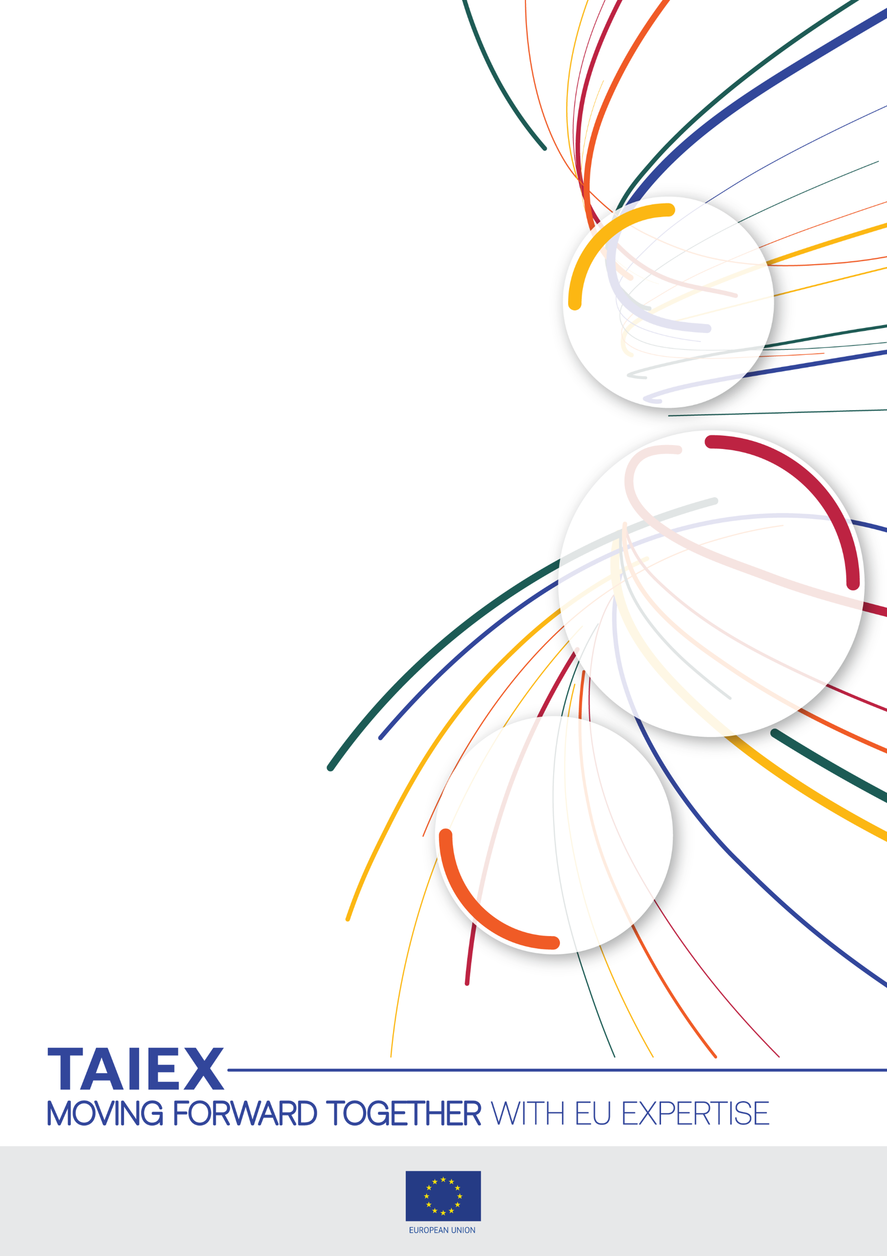



TAIEX Study Visit on Environmental Liability Directive (ELD) in Environmental Inspection Practices
Organized in co-operation with
Ministry for Ecology, Sustainable Development and Norther Region Development, Montenegro / ISPRA, Italy
24 - 26 March 2026
Venue:
ISPRA via Vitaliano Brancati 48,
00144 Rome (Italy)
Meeting Room n. 117 - 1st Floor
Beneficiary:
Montenegro

TAIEX Case ID ETT IND/STUD 91928



Aim of the Study Visit:
The objective of this study visit is to enhance the capacity of environmental inspectors in Montenegro to effectively implement and enforce the Environmental Liability Directive (2004/35/EC), with a particular focus on addressing environmental damage caused by negligence. Through this study visit, participants aim to gain practical insights into how EU Member States apply the ELD in real-life cases, including methodologies for identifying environmental damage, conducting inspections, initiating remediation measures, and ensuring the "polluter pays" principle is upheld.

The visit will also support Montenegro’s alignment with EU environmental acquis in the context of Chapter 27 – Environment and Climate Change, by improving knowledge and skills necessary for transposing and applying the ELD, including institutional cooperation and judicial follow-up in environmental liability cases.
During the meeting, Italy will present its institutional and operational framework for the implementation of the EU environmental acquis, illustrating how European directives, once transposed into national law, are made operational within a complex, multi-level administrative structure. The distinction between inspection activities and the management of environmental damage reflects the current allocation of competences among the State, Regions, and other institutional actors, as well as the need to ensure compliance with sector-specific implementing legislation. In this context, the National System for Environmental Protection (SNPA) plays a coordinating role aimed at promoting the harmonization of operational practices and consistency of application across the territory. The presentation is intended to show how the objectives set out in EU directives are translated into concrete implementation, providing useful elements for Montenegro to define its own framework in line with the EU acquis.

Speakers / Participants:
Participants from Host Institution

ISPRA: International Affairs Unit
- Ms Stefania Minestrini
[Head of Unit]
- Ms Sandra Moscone
[Senior Expert]
- Mr Enrico de Zorzi
[Senior Expert]

ISPRA: National Centre for Environmental Crises, Emergencies and Damage

- Mr Antonio Guariniello
[Senior Expert]
- Ms Paola di Toppa
[Head of Unit]
- Mr Daniele Montanaro
[Head of Section]
- Ms Marina Cerra
[Senior Expert]
- Ms Angela Sarni
[Senior Expert]
- Ms Mariachiara Barile
[Senior Expert]
- Mr Francesco Andreotti
[Head of Section]

ISPRA: Unit for Risks and Sustainability of Technologies, Chemicals, Production Cycles and Water Services and for Environmental Inspection Activities

- Mr Romualdo Marrazzo
[Head of Section]
- Mr Fausta Delli Quadri
[Senior Expert]
- Mr Francesco Astorri
[Senior Expert]
- Mr Fabrizio Vazzana
[Head of Section]

- Mr Roberto Borghesi
[Head of Section]
- Mr Alessandro Stracqualursi
[Expert]
- Ms Geneve Farabegoli
[Head of Section]
- Ms Valeria Canè
[Head of Section]
- Ms Lucia Lumia
[Expert]

ISPRA: Unit for Assessment, Prevention and Control of Environmental Pollution from Physical Agents
- Ms Francesca Sacchetti
[Head of Unit]
- Mr Enrico Mazzocchi
[Senior Expert]
- Mr Giuseppe Marsico
[Head of Section]
- Mr Daniele Franci
[Senior Expert]

ISPRA: Unit for Integrated and Strategic Environmental Assessments and Interactions between Environment and Health
- Ms Anna Cacciuni
[Head of Section]

Ministry of Environment and Energy Security (MASE) -Italy
- Mr Massimo Scambia
[Administrative officer, Deputy Head of Division VI (Environmental Damage) - Directorate General Circular Economy and Site Remediation]
- Ms Cinzia Panarese
[Legal Consultant of Division VI (Environmental Damage) - Directorate General Circular Economy and Site Remediation]
- Mr Fabrizio Palazzini
[Legal Consultant of Division VI (Environmental Damage) - Directorate General Circular Economy and Site Remediation]

Participants from Ministry for Ecology, Sustainable Development and Norther Region Development - Montenegro
- Ms Veselinka Zarubica
Ecological inspector
Ministry of ecology, sustainable development and northern region development
- Ms Slavena Vukovic
Ecological inspector
Ministry of ecology, sustainable development and northern region development,
- Ms Slavica Braunovic
Advisor
Ministry of ecology, sustainable development and northern region development
- Ms Maja Raicevic
Advisor
Ministry of ecology, sustainable development and northern region development
- Mr Milan Vlahovic
Advisor
Environmental Protection Agency.
Data Protection: Personal data contained in this document is processed in accordance with the privacy statement of the TAIEX instrument in compliance with Regulation (EU) 2018/1725. The chairperson should inform all persons attending the event that photographs/pictures should only be taken during a set period of time to allow for persons who do not agree to have their photographs taken to leave the room, unless all of the participants have provided their express consent to having their photograph taken. See
https://enlargement.ec.europa.eu/document/download/fc180dd7-6649-4914-875e-45fc4429ff83_en?filename=taiex_privacy_statement.pdf

Day 1: Tuesday 24 March 2026
ELD Framework and SNPA Technical Procedures - Chair Ms Marina Cerra
Venue: ISPRA via Vitaliano Brancati 48, 00144 Rome (Italy)
Interpretation: IT-ME/ME-IT
Local time  9:30 – 09:45 | Registration.  Goal of the day: to align the delegation on how Italy implements the Environmental Liability Directive (ELD) at the operational level, and how ISPRA coordinates prevention, assessment, remediation of environmental damage (CN CRE DAN- National Centre for Environmental Crises, Emergencies and Damage)
09:45 - 10:00 | Welcome and introduction: Institutional greetings, opening and objectives  - Presentation of the programme and expected outcomes  Speakers: Ms Stefania Minestrini (ISPRA), Mr Massimo Scambia (MASE)
10:00 – 10:20 | Presentation of the Montenegrin context  - State of play of legislation alignment, inspection practices and main challenges  Speaker: Ms Veselinka Zarubica, Ms Slavena Vukovic, Ms Slavica Braunovic, Ms Maja Raicevic, Mr Milan Vlahovic
10:20– 11:00 | ELD in practice: principles, scope of application  - Core principles of the Directive, initiation of preventive and remedial actions.  - ELD implementation in Italian legislation  Speaker: Mr Antonio Guariniello
11:00 – 11:10 | Break
11:10– 11:50 | MASE Expert: Overview of the Italian institutional context  Speakers: Ms Cinzia Panarese, Mr Fabrizio Palazzini
11:50 – 12:30 | Technical support to the Ministry of the Environment: emergencies, critical issues, and damage assessment  - Operational lines of action for emergencies and environmental damage (judicial and administrative procedures)  - ISPRA/SNPA technical territorial support  Speaker: Ms Paola Di Toppa
12:30 – 14:00 | Lunch break
14:00 – 14:45 | Documentation and evidence standards and procedures to assess environmental damage  - Formats for notification and reports; evidentiary elements required to initiate remedial measures.  - Analysis of a typical incident, critical decisions, activation of urgent measures, and preliminary damage estimates  Speaker: Mr Daniele Montanaro
14:45 – 15:00 | Break
15:00 – 16:00 | Structured Q&A and check-out of key learnings  Closing, AOB and wrap up of day 1  Speaker: Chair Ms Marina Cerra

Day 2: Wednesday 25 March 2026
ISPRA’s Inspection Activities - Chair Mr Fabrizio Vazzana
Local time  9:30– 09:45 | Registration  Goal of the day: to transfer inspection methods, risk-based planning tools, and measurement protocols that make ELD “actionable”  VAL Dept Environmental Assessment, monitoring and Sustainability
09:45 – 10:45 | Integrated environmental inspections and controls:  - ISPRA’s role and organization in Environmental Impact Assessment (EIA)  - ISPRA’s role and organization in Integrated Environmental Authorisation (IEA)  - Annual reports: the case of the Water-Energy Nexus in thermoelectric power plants  - ISPRA’s role as control Authority for Italian industrial plants  - SEVESO controls and possible synergies with IPPC-IED  Speakers: Ms Anna Cacciuni, Mr Roberto Borghesi, Mr Alessandro Stracqualursi, Mr Romualdo Marrazzo, Ms Lucia Lumia
10:45 – 11:00 | Break
11:00 – 11:45 | Tools for planning and conducting Seveso Inspections  - Operational instruments for inspections  - Operational instruments required by regulations (inventory and related databases, checklists, templates) for Seveso Inspections and Controls  Speakers: Mr Francesco Astorri, Mr Fabrizio Vazzana
11:45 – 12:30 | Seveso Case Study  - Assessments carried out following major accidents  - Lessons learned and operational experience from a major accident impacting human health and environmental matrices  Speakers: Mr Romualdo Marrazzo, Ms Fausta Delli Quadri
12:30 – 14:00 | Lunch break
14:00 – 14:45 | IED Case Study  - From inspection planning to notification of non-compliances  - How to deal with inspections in wastewater treatment plants  - Integrated steel plant in Taranto: environmental inspections in the National System for Environmental Protection and use of drones.  Speakers: Ms Geneve Farabegoli, Ms Valeria Canè
14:45 – 15:00 | Break
15:00 – 16:00 | Structured Q&A and check-out of key learnings  Closing, AOB and wrap up of day 2  Speaker: Chair Mr Romualdo Marrazzo

Day 3: Thursday 26 March 2026
ELD Exercise, Costs, and Inter-Agency Coordination - Chair Ms Paola di Toppa
Local time 9:30 – 09:45 | Registration of participants  Goal of the day: to validate competencies through a complete ELD tabletop exercise, including remediation estimation and institutional cooperation
09.45 – 10:15 | Physical Agents evaluation and inspections activities  - Environmental Impact assessment procedures on Physical Agents:  - Environmental noise  - Electromagnetic fields  - Market surveillance and inspection activities on Directive 2000/14/EC; examples of non-compliance, requirements, and corrective actions  Speakers: Ms Francesca Sacchetti, Mr Giuseppe Marsico, Mr Enrico Mazzocchi, Mr Daniele Franci
10:15 – 10:45 | IMPEL Projects for Enforcement of the ELD  Speaker: Mr Francesco Andreotti
10:45 – 11:00 | Break
11:00 – 11:30 | Decision-making model and the “polluter pay” principle  Selection of remedial measures and initiation of the design and execution phases by the responsible operator (PPP principle under ELD)  Speakers: Ms Angela Sarni, Ms Marina Cerra
11:30 – 12:30 | ELD Case study  - Environmental damage from hydroelectrical basin  - Competent authority, inspectorate, operator, technical support; documentation  workflow; criteria for proposing and implementing preventive and remedial  measures  Speaker: Ms Mariachiara Barile
12:30 – 14:00 | Lunch break
14:00 – 14:45 | Coordination with SNPA/ARPA and with prosecutors/law enforcement  - Operational channels, data exchange, minimum evidence standards, when and how to escalate a case  - Case study  Speakers: Mr Romualdo Marrazzo, Ms Marina Cerra
14:45–15:00 | Break
15:00 – 16:00 | Structured Q&A and check-out of key learnings  Closing, AOB and wrap up of day 2  End of the Study Visit  Speaker: Chair Ms Paola di Toppa



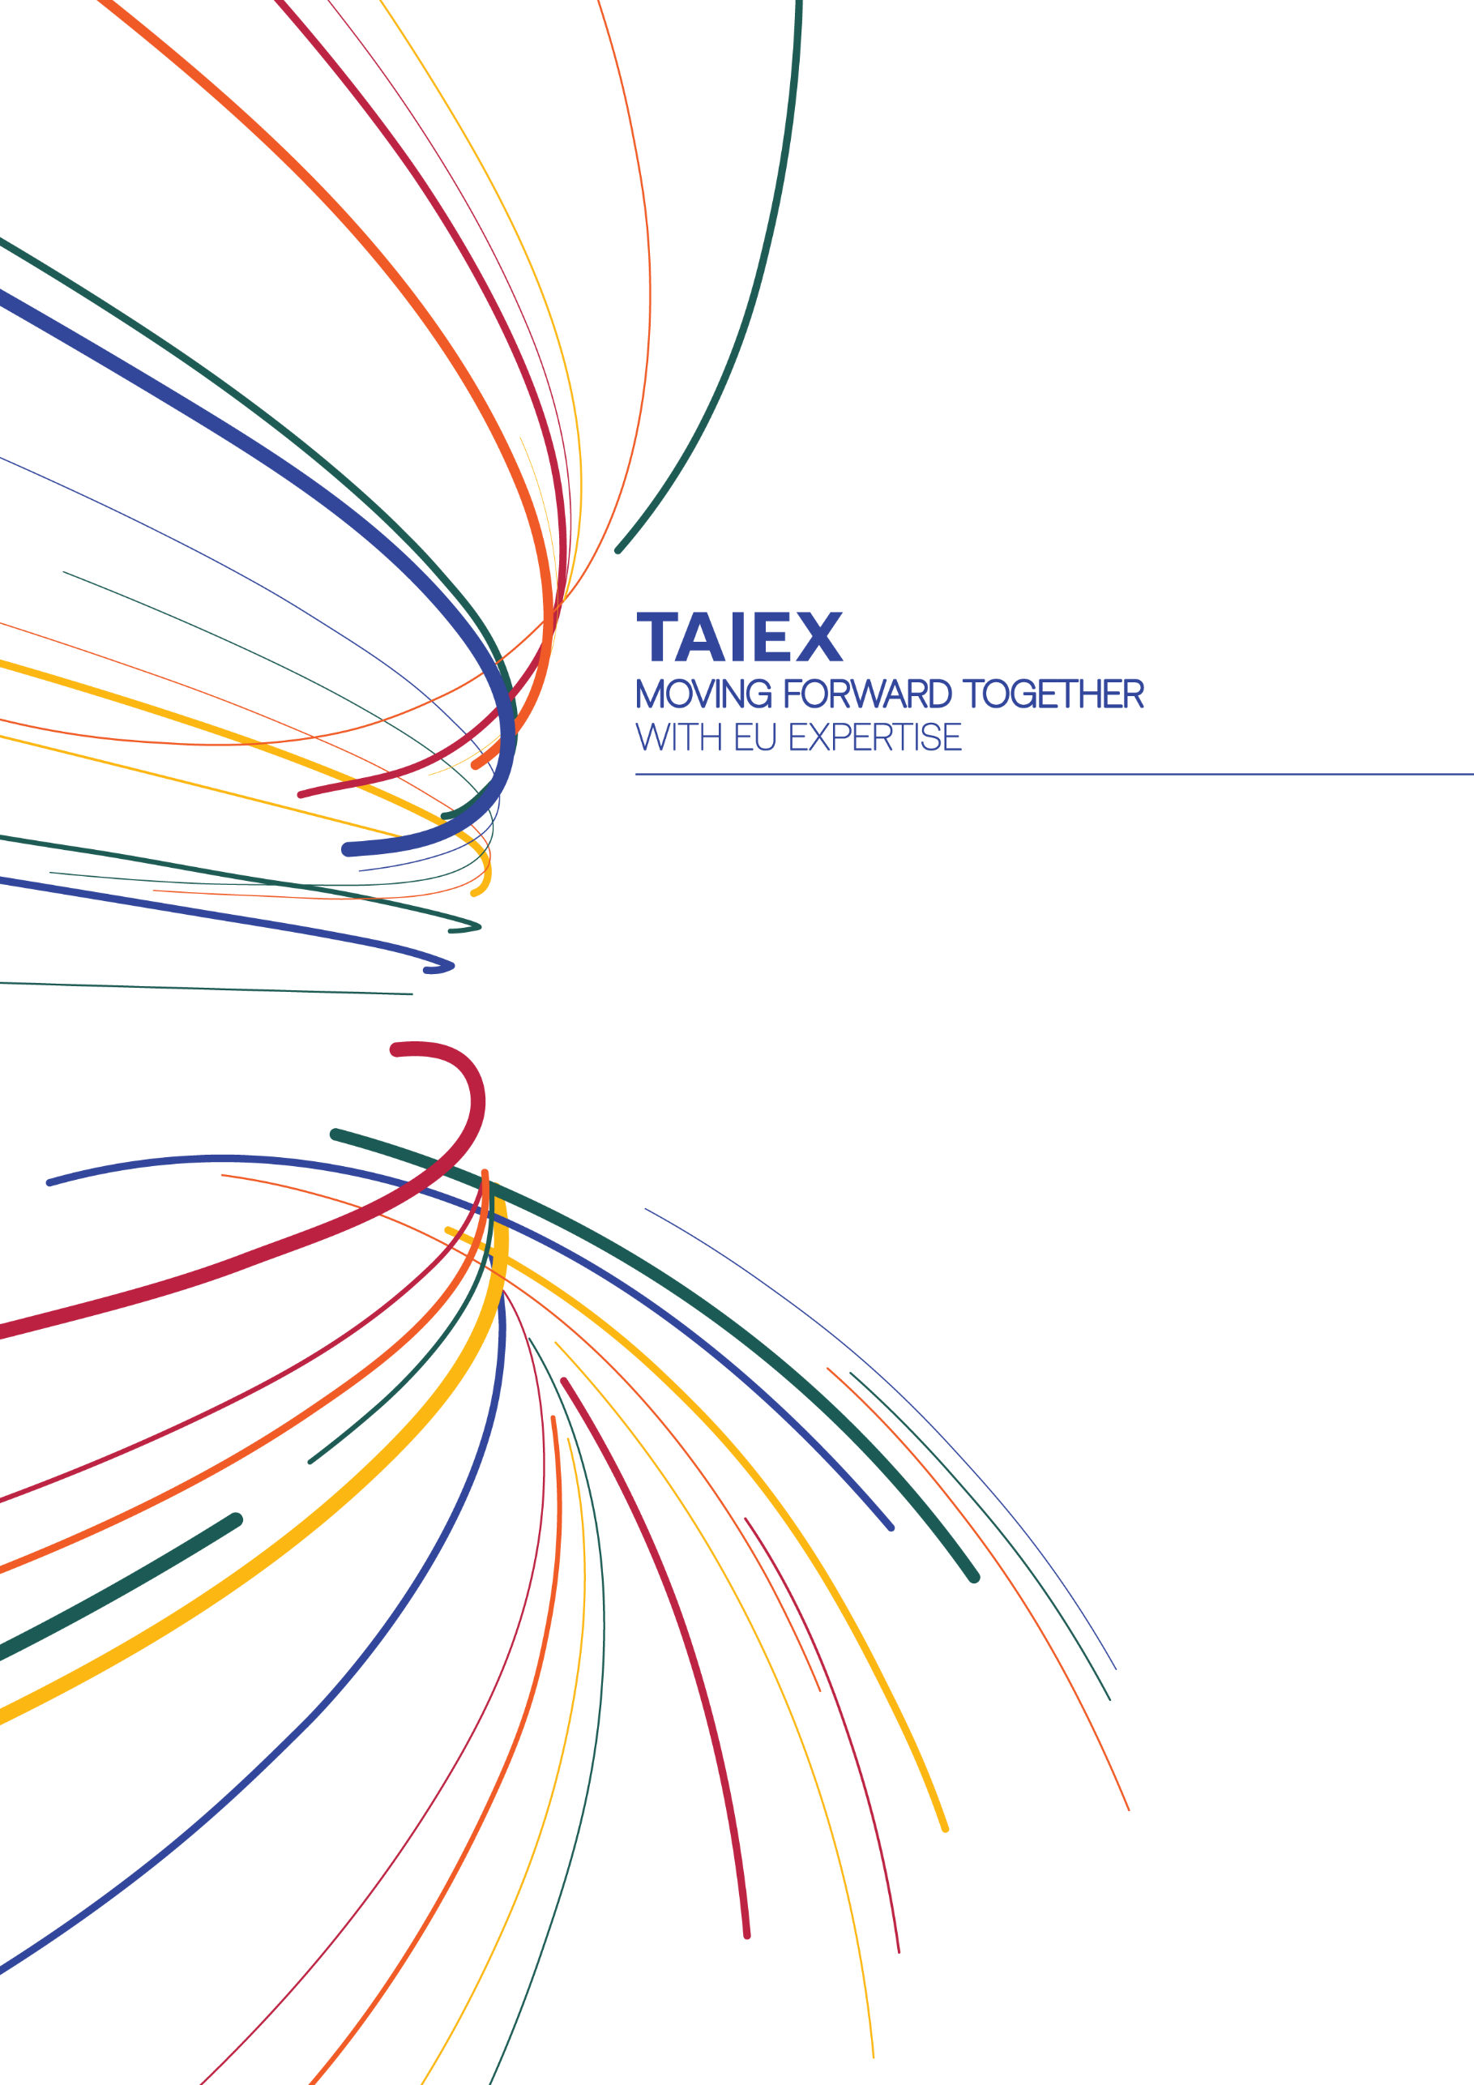
ENEST-TAIEX@ec.europa.eu

ec.europa.eu/taiex



